W316R,W308R,W309R-How to upgrade the software of the router
Product line: wireless question category: function config

Q: Why we need to upgrade firmware for the router?
A: Sometimes we may need to Upgrade the router to another firmware version if the current firmware version can no longer satisfies your requirement. For example, the new firmware will be of great valve to fix some bugs and to achieve better service.

Warning:
1. Upgrade with Ethernet cable, do not upgrade wirelessly, it may cause failure and damage the router.
2. Do not Power off the router when upgrading
3. Do not upgrade remotely, please just directly connect your PC and router and perform the upgrade.

Connection Topology is as below:
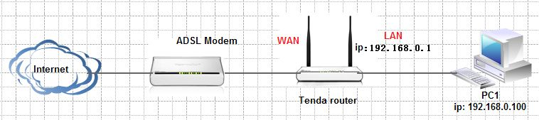

The steps are as below
- Download the correctly firmware from our web site www.tenda.cn to your computer.

- Please connect your computer to the yellow port of the router with an Ethernet cable, power on your devices.

- Login the management page of the router.

4， On the top bar, please find System Tools and click on it, under System tools please find Upgrade and click on it, then you are in the Upgrade page.

5， Click on the button named Browse…, then find the new software on your computer and add it into the blank before Browse…, and then click on Upgrade, after that, the router will reboot automatically
